**UNIVERSITI MALAYSIA TERENGGANU**

**SEMESTER 1 2023/2024**

**CYBER SECURITY CSF3233**

**LAB 1**

**PREPARED FOR:**

**MUHAMMAD ABDUL AALIM AHMAD ROSLI**

**PREPARED BY:**

**ARUN MUGILAN A/L SARGUNAN S63746**

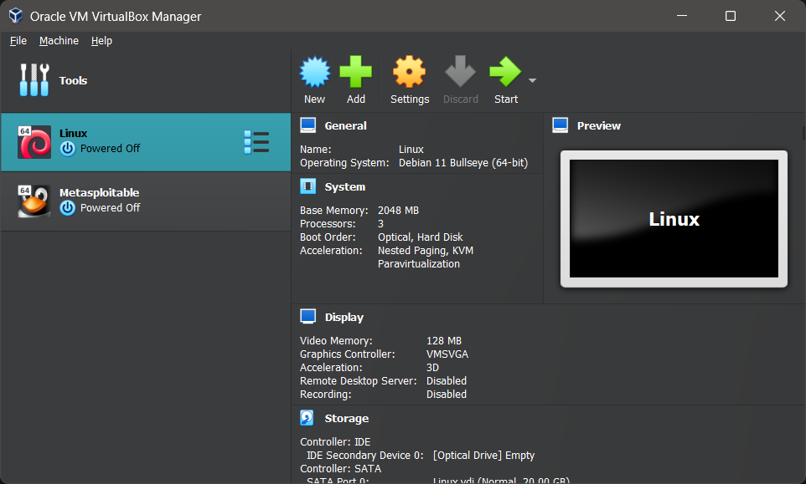

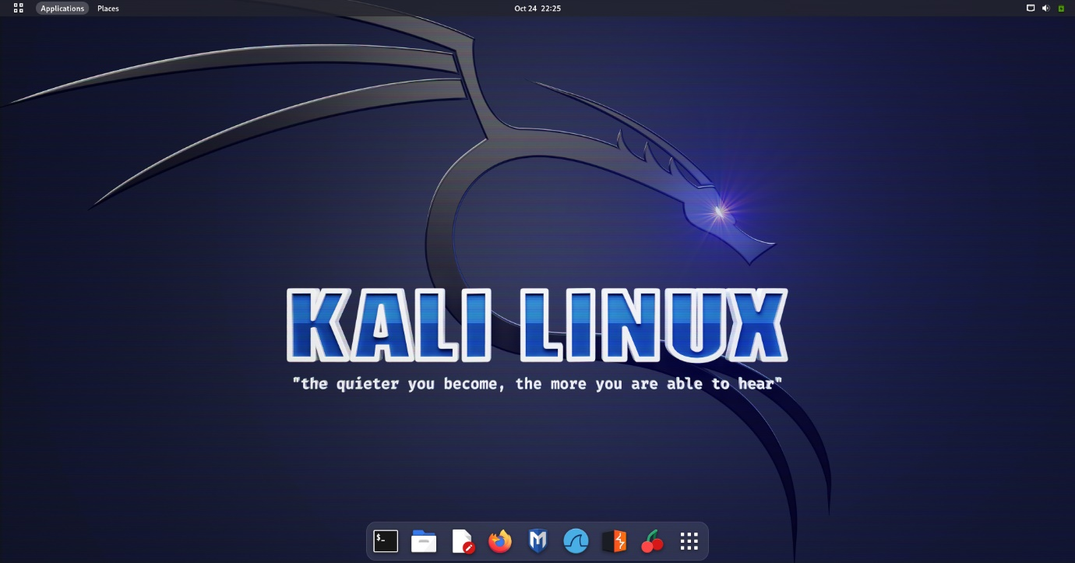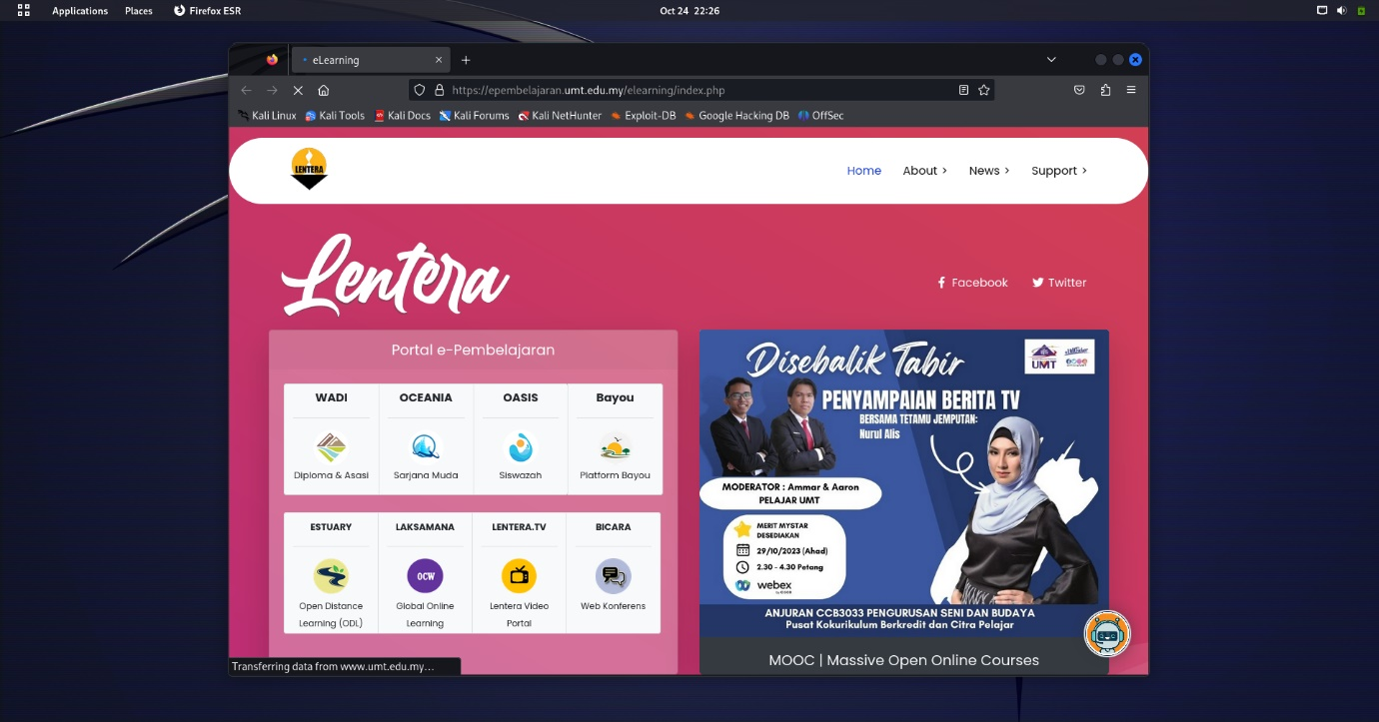

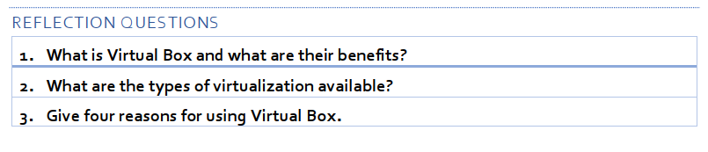

1. The most widely used open source cross-platform virtualization programme in the world, Oracle VM VirtualBox, helps developers to produce code more quickly by allowing them to run different operating systems on a single device.
2. Types of virtualization
   * Desktop virtualization.
   * Network virtualization.
   * Storage virtualization.
   * Data virtualization.
   * Application virtualization.
   * Data center virtualization.
   * CPU virtualization.
   * GPU virtualization.
3. Running numerous operating systems at the same time. Oracle VM VirtualBox allows you to run multiple operating systems at the same time. Software installation is simplified. Disaster recovery and testing. Infrastructure reorganisation. It enables users to install and run different operating systems at the same time by allowing them to create and run virtual machines on their PCs.

1. It is an operating system designed for conducting security assessments, network testing, and digital forensics
2. Kali Linux is mostly used to launch advanced-level security audits and penetration tests. The operating system includes a plethora of tools for activities such as information security, security research, penetration testing, reverse engineering, and computer forensics.
3. Reasons to use Kali Linux

* There are almost 600 penetrating tools provided.
* Compliance with the file-system hierarchy standard.
* Navigate to the development tree.
* Support for multiple languages.
* Totally customisable.
* Support for a wide range of wireless devices.

